Precondition Setting

Step 1:

Install the Chrome browser and make sure the chromedriver.exe is same with chrome browser version.

Step 2:

Install the python 3.6.8, and don’t forget join the “path” under the user variable.

(Reference for Step 5)

Step 3:

Update the Setuptools and pip version:

* python –m pip install –upgrade pip setuptools
* pip –V (make sure the newest version on your system)

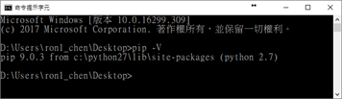

Step 4:

Install the JDK of 6u45 and 7u79 version.

Step 5:

Modify your system and environment variables (use the appropriate Java version):

* Add to Environment Variables
  + JDK_HOME: C:\Program Files (x86)\Java\jdk1.7.0_79
  + PATH: C:\Program Files (x86)\Java\jdk1.7.0_79\jre\bin\server
  + PATH: C:\Program Files (x86)\Java\jre6\bin
* Add to System Variables:
  + _JAVA_OPTIONS: -Xmx512M

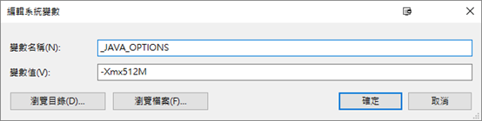

* + PATH: C:\Program Files (x86)\Java\jdk1.6.0_45\bin
  + PATH: C:\Program Files (x86)\Java\jdk1.6.0_45\jre\bin
  + PATH: C:\Program Files (x86)\Java\jdk1.7.0_79\bin

Step 5:

Install the tool of Sikuli-IDE, and then replace the Sikuli-IDE folder to last version.

Step 6:

Install the “vs buildtools”, “AutoIT” and “Appium”

Step 7:

Install the Envir_Install.py library by 3.6.8 version.

* python Envir_Install.py
* python setup.py install for sikulitool

Step 8:

Finally, please make sure the jnius and sikulitools API have been installed and worked properly on your system.

